**KANA CI & CD**

There is no build strategy in KANA.

“.tem” files are the artifacts to be deployed. Hence these files are fetched by Jenkins and pushed to UrbanCode Deploy.

Below figure illustrates the flow involved in CI, CD and CT for KANA application:

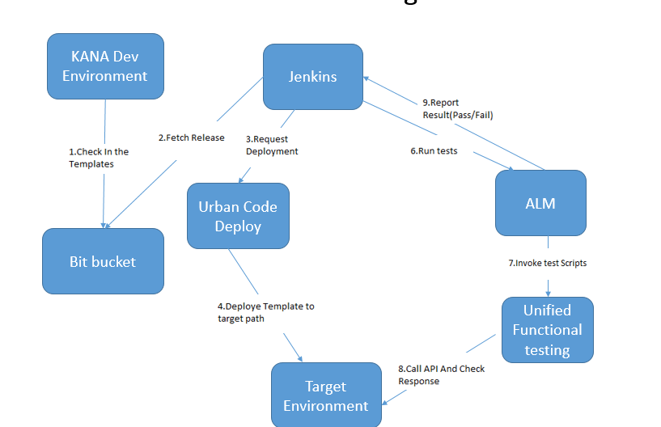

**Environments in use**

All KANA IQ servers are Windows 2016 servers

|  |  |  |  |  |  |
| --- | --- | --- | --- | --- | --- |
| Environment | Type | Host | IP | Id | serviceAcc |
| DEV - A | IQ server 15.2 | rbdeachkiqmww01 | 10.71.101.23 | 10.71.101.23\kanaapp | Kanaapp |
|  |  |  |  |  |  |
| DEV - B | IQ server 15.2 | rbdecchkiqmww01 | 10.71.101.24 | 10.71.101.24\kanaapp | kanaapp |
|  |  |  |  |  |  |
| DEV - C | IQ server 15.2 | rbdebchkiqmww01 | 10.71.101.35 | 10.71.101.35\kanaapp | kanaapp |
|  |  |  |  |  |  |
| CIT - A | IQ server 15.2 | rbciachkiqmww01 | 10.70.101.34 | 10.70.101.34\kanaapp | kanaapp |
|  |  |  |  |  |  |
| CIT - B | IQ server 15.2 |  |  |  |  |
|  |  |  |  |  |  |
| CIT - C | IQ server 15.2 | rbcicchkiqmww01 | 10.70.101.35 | 10.70.101.35\kanaapp | kanaapp |
|  |  |  |  |  |  |
| SIT - A | IQ server 15.2 | rbsiachkiqmww01 | 172.28.196.9 | 172.28.196.9\kanaapp | kanaapp |
|  |  |  |  |  |  |
| SIT - B | IQ server 15.2 |  |  |  |  |

**List of Agents**

DEV-A Channels-Kana-IQ.DEV-A.10.71.101.23

DEV-B Channels-Kana-IQ.DEV-B.10.71.101.24

DEV-C Channels-Kana-IQ.DEV-C.10.71.101.35

CIT-A Channels-Kana-IQ.CIT-A.10.70.101.34

CIT-C Channels-Kana-IQ.CIT-C.10.70.101.35

SIT-A Channels-Kana-IQ.SIT-A.172.28.196.9

**Note:** All the agents are running under service user account “kanaapp” in order to avoid permission issues to the “data” folder in KANA installation directory. Below property should be set as soon as agent is installed, as KANA IQ server installation path is not common for all the environments:

**Property:**

KANA_DATA

DEV-A F:\KANAIQ\IQ\data

DEV-B F:\KanaIQ\IQ\data

DEV-C F:\KANA\KANAIQ\IQ\data

CIT-A F:\KANA\IQ\data

CIT-C F:\KANAIQ\IQ\data

SIT-A F:\KANAIQ\IQ\data

**CI and CD**

Template files are present in the data directory in the installation path.

“data” directory is treated as the base directory from which “.tem” files are pushed into BitBucket. All the code in the branch is integrated using Jenkins and pushed to UrbanCode Deploy.

**Pipelines setup in Jenkins:**

Channels-KANA-DEV-A-Deploy : For Daily deployments of the ongoing release (feature/release_name branch) on DEV-A

Channels-KANA-DEV-A-Pipeline : For promotions to higher environments

Channels-KANA-DEV-B-Pipeline

Channels-KANA-CIT-A-Pipeline

Channels-KANA-CIT-B-Pipeline

Channels-KANA-CIT-C-Pipeline

Channels-KANA-SIT-A-Pipeline

**Delivery Pipeline View:**

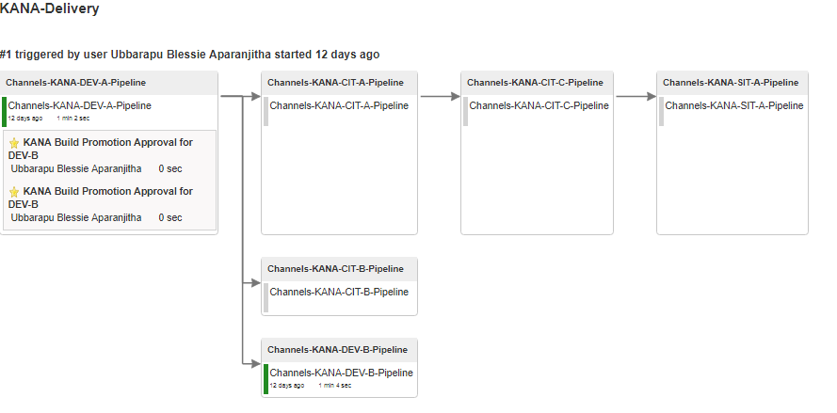

**Steps involved in Deployment:**

**getDate** : Get the timestamp and store in property, which will be used to create backup directories with timestamp

**Create base backup directory** : Create a base backup directory in which backup directories with timestamp are created

**Create backup directory with timestamp** :Create backup directories with timestamp inside base backup directory

**Take backup of existing template sets** : Take a backup of the existing files in data directory

**Deploy tem files** : Deploy the new tem files (use download artifacts plugin in sync mode)

**Description and Details of steps involved in Deployment**

**getDate**

script**:**

$date=Get-Date -format MM.dd.yyyy-HH.mm.ss

Write-Host "DATE=$date"

Post-processing script:

var exit = properties.get('exitCode');

if (exit == -128) {

properties.put('Status', 'Success');

scanner.register("DATE=", function(lineNumber, line) {

var value=line.replace("DATE=","");

properties.put("backup_date",value);

});

scanner.scan();

}

else {

properties.put('Status', 'Failure');

}

**Create base backup directory**

Working Directory : F:\

Script:

if not exist "kana_backup" mkdir kana_backup

**Create backup directory with timestamp**

Working Directory : F:\kana_backup

Script:

mkdir kana-${p:getDate/backup_date}

**Take backup of existing templatesets:**

Working Directory : ${p:agent/KANA_DATA}

Copy tem files along with directory structure:

xcopy *.tem F:\kana_backup\kana-${p:getDate/backup_date} /sy

**Deploy tem files**

Deploy the new tem files (use download artifacts plugin in sync mode)

Working Directory : ${p:agent/KANA_DATA}

**Dev Team:**

DV00517044@TechMahindra.com

SM00505483@TechMahindra.com

MM00504582@TechMahindra.com

VK00465616@TechMahindra.com